# VISVESVARAYA TECHNOLOGICAL UNIVERSITY

**“Jnana Sangama”,** Belgaum-590018.

DBMS mini Project On

**“Railway Reservation System”**

### Submitted in partial fulfillment for the requirements of the V Semester degree of

**BACHELOR OF ENGINEERING IN**

**INFORMATION SCIENCE AND ENGINEERING**

#### For The Academic Year 2021-2022

**By**

**Sujith M**

**(1DB19IS091)**

**Under the Guidance of**

**Prof.Basavaraj Neelagund Prof.Rohini B.R.**

**Asst.Professor,Dept.Of ISE**



### Department of Information Science and Engineering

**DON BOSCO INSTITUTE OF TECHNOLOGY**

**Kumbalagodu, Mysore Road, Bengaluru - 560 074.**

**ACKNOWLEDGEMENT**

Here by I am submitting the CG mini project report on **“Railway Reservation System”**, as per the scheme of Visvesvaraya Technological University, Belgaum.

In this connection, I would like to express my deep sense of gratitude to my beloved institution Don Bosco Institute of Engineering and also I like to express my sincere gratitude and indebtedness to **Dr.Hemadri Naidu T, Principal, DBIT, Bangalore.**

I would like to express my sincere gratitude to **Prof.Gowramma G.S.** Professor and Head of Dept. of Information Science and Engineering, for providing a congenial environment to work in and carryout my mini project.

I would like to express the deepest sense of gratitude to thank my Project Guide **“Prof.Basavaraj N & Prof Rohini R.R.**, Asst. Professor, Department of Information Science and Engineering, DBIT, Bangalore for their constant help and support extended towards me during the course of the project.

Finally I am very much thankful to all the teaching and non teaching members of the Department of Information Science and Engineering, my seniors, friends and my parents for their constant encouragement, support and help throughout completion of report.

**SUJITH M (1DB19IS092)**

**DON BOSCO INSTITUTE OF TECHNOLOGY**

**Kumbalagodu, Bengaluru – 560 074.**

**DEPARTMENT OF INFORMATION SCINECE AND ENGINEERING**

**CERTIFICATE**

This is to certify that the mini project report entitled **“ Railway Reservation System”** is a bonafide work carried out by **Sujith M (1DB19IS091)** in partial fulfillment of award of Degree of **Bachelor of Engineering in Information Science and Engineering** of Visvesvaraya Technological University, Belagavi, during the academic year 2021-2022. It is certified that all corrections/suggestions indicated for Internal Assessment have been incorporated. The mini project has been approved as it satisfies the academic requirements associated with the degree mentioned.

**Signature of guide Signature of HOD**

**………………… ………………….**

**Mr.Basavaraj N. & Mrs.Rohini B.R. Prof. Gowramma G.S.**

Asst. Professor Head of Dept.,

Dept. of ISE, Dept. of ISE,

DBIT, Bengaluru. DBIT, Bengaluru.

**TABLE OF CONTENTS**

|  |  |  |  |
| --- | --- | --- | --- |
| 1 |  | **INTRODUCTION** | 5 |
|  | 1.1 | Database environment | 7 |
|  | 1.2 | Advantages of DBMS | 8 |
|  | 1.3 | Architecture of database | 9 |
| 2 |  | **INTRODUCTION TO THE PROJECT** | 10 |
|  | 2.1 | Brief description | 10 |
|  | 2.2 | Scope | 11 |
|  |  | Table description | 12 |
| 3 |  | **DESIGN** | 13 |
|  | 3.1 | ER Diagram | 13 |
|  | 3.2 | Normalization | 14 |
|  | 3.3 | Schema diagram | 14 |
| 4 |  | **HARDWARE AND SOFTWARE REQUIREMENTS** | 15 |
|  | 4.1 | Functional Requirements | 15 |
|  | 4.1.2 | Non functional Requirements | 15 |
|  | 4.2 | Hardware requirement | 16 |
|  | 4.3 | Software requirements | 16 |
| 5 |  | **CONCLUSION** | 17 |
| 6 |  | **FUTURE ENHANCEMENT** | 18 |
| 7 |  | **BIBLIOGRAPHY** | 19 |
| 8 |  | **SNAPSHOTS** | 20 |
|  |  |  |  |

**CHAPTER – 1 INTRODUCTION TO DATABASE**

Database and database technology has a major impact on the growing use of computers. It is fair to say that databases play a critical role in almost all areas where computers are used, including business, electronic commerce, engineering, medicine, genetics, law, education, and library science.

The word database is so commonly used that we must begin by defining what the database is. Our initial definition is quite general. A database is a collection of related data. By data, we mean known facts that can be recorded and that have implicit meaning. For example, consider the names, telephone numbers, and addresses of the people you know. You may have recorded this data in an indexed address book or you may have stored it on a hard drive, using personal computers and software such as Microsoft excel. This collection of related data with an implicit meaning is a database.

The preceding definition of a database is quite general, for example, we may consider the collection of words that make up this page of text to be related data and hence to constitute a database. However, the common use of the term database is usually more restricted. A database has the following properties:

A database represents some aspect of the real world, sometimes called the mini world or the universe of discourse. The changes to the mini world are reflected in the database. A database is a logically coherent collection of data with some inherent meaning. A random assortment of data cannot correctly be referred to as a database. A database is designed, built and populated with data for a specific purpose. It has an intended group of users and some preconceived applications in which these users are interested.

In other words, a database has some source from which data is derived, some degree of interaction with events in the real world, and an audience that is actively interested in its contents. The end-users of the database may perform business transactions (for example a customer buys a camera) or events may happen that may cause the information in the database to change. In order for a database to be accurate and reliable at all times, it must be a true reflection of the mini world that it represents; therefore changes must be reflected in the database as soon as possible.

A database can be of any size and complexity. A database may be generated and maintained manually or computerized. For example, a library card catalog is a database that may be created and maintained manually. A computerized database may be created and maintained either by a group of application programs written specifically for that task or by a database management system. A database is a collection of data, typically describing the activities of one or more related organizations. For example, a university database might contain information about the following

Entities such as students, faculty, courses, and classrooms. Relationships between entities, such as student’s enrolment in courses, faculty teaching courses, and the use of rooms for courses.

**File system versus DBMS**

To understand the need for a DBMS, let us consider a motivating scenario: a company has a large collection (say 500 GB) of data on employees, departments, products, sales, and so on. This data is accessed concurrently by several employees. Questions about the data must be answered quickly, changes made to the data by different users must be applied consistently and access to certain parts of the data must be restricted. We can try to manage the data by storing it in operating system files. This approach has many drawbacks, including the following

● We probably do not have 500GB of main memory to hold all the data. We must, therefore, store data in a storage device such as a disk or tape and bring relevant parts into the main memory for processing as needed.

● Even if we have 500 GB of main memory, on computer systems with 32 bit addressing, we cannot refer directly to more than about 4 GB of data. We have to program some method of identifying all data items. ● We have to write special programs to answer each question a user may want to ask about the data. These programs are likely to be complex because of the large volume of data to be searched.

● We must protect the data from the inconsistent changes made by different users accessing the data concurrently. If applications must address the details of such concurrent access, this adds greatly to their complexity.

● We must ensure that the data is restored to a consistent state if the system crashes while changes are being made.

● Operating systems provide only a password mechanism for security. This is not sufficiently flexible to enforce security policies in which different users have permission to access different subsets of the data. A DBMS is a piece of software designed to make the preceding tasks easier. By storing data in DBMS rather than as a collection of operating system files, we can use the DBMS’s features to manage the data in a robust and efficient manner. As the volume of data and the number of users grow hundreds of gigabytes of data and thousands of users are common in current corporate database DBMS support becomes indispensable.

* 1. **DATABASE ENVIRONMENT SYSTEM**

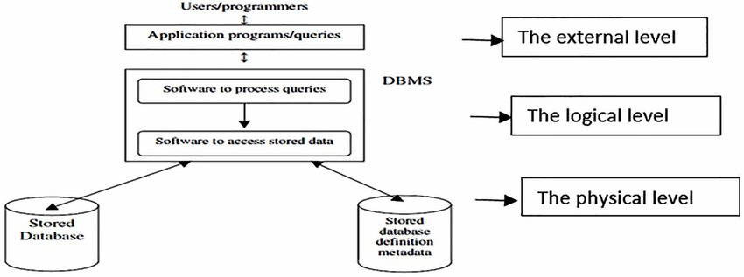

Fig 1.1

The database definition or description information is also stored by the DBMS in the form of a database catalog or dictionary, it is called Metadata. Constructing the database is the process of storing the data on some storage medium that is controlled by the DBMS. Manipulating a database includes functions such as querying the database to retrieve specific data, updating the database to reflect changes in the mini world and generating reports from the data. Sharing a database allows multiple users and programs to access the database simultaneously.

An application program accesses the database by sending queries or requests for data to DBMS. A query typically causes some data to be retrieved; a transaction may cause some data to be read and some data to be written into the database.

Other important functions provided by DBMS include protecting the database and maintaining it over a long period of time, protection includes system protectionagainst hardware or software malfunction and security protection against unauthorized or maliciousaccess. A typical large database may have a life cycle of many years, so the DBMS must be able to maintain the database system by allowing the system to evolve as requirements change over time.

It is not absolutely necessary to use general-purpose DBMS software to implement a computerized database. We could write our own set of programs to create and maintain the database, in effect creating our own special purpose DBMS software. In either case, whether we use a general-purpose DBMS or not we usually have deployed a considerable amount of complex software. In fact, most DBMSs are very complex software systems. Fig 1.1 shows a simplified database environment system.

* 1. **ADVANTAGES OF USING DBMS APPROACH**

Using a DBMS to manage data has many advantages:

● Data independence: application program should not, ideally, be expected to details of data representation and storage, the DBMS provides an abstract view of the data

● Efficient Data Access: A DBMS utilizes a variety of sophisticated techniques to store and retrieve data efficiently. This feature is especially important if the data is to be stored on an external device. ● Data integrity and security: if data is always accessed through DBMS, the DBMS can enforce integrity constraints. For example, before inserting salary information for an employee, the DBMS can check that the department budget is not exceeded. Also, it can enforce access controls that govern what data is visible to different classes of users.

● Data Administration: when several users share data, centralizing the administration of data can offer significant improvements. Experienced professionals who understand the nature of the data being managed, and how different groups of users use it, it can be responsible for organizing the data representation to minimize redundancy and for fine-tuning the storage of the data to make retrieval efficient.

● Concurrent Access and Cash Recovery: A DBMS schedules concurrent accesses to the data in such a manner that users can think of the data as being accessed by only one user at a time. Further, the DBMS protects users from the effects of system failures.

● Reduced Application Development Time: clearly, the DBMS supports important functions that are common to many applications accessing data in the DBMS. This, in conjunction with the high-level interface to data, facilities quick application development. DBMS applications are also likely to be more robust than a similar stand-alone application because many important tasks are handled by the DBMS.

* 1. **ARCHITECTURE OF DATABASE**

The Three-Schema Architecture The goal of the three-schema architecture illustrated in the figure is to separate the user application from the physical database. In this architecture, schemas can be defined at the following three levels:

● The internal level has an internal schema, which describes the physical storage structure of the database. The internal schema uses a physical data model and describes the complete details of data storage and access paths for the database.

● The conceptual level has a conceptual schema, which describes the structure of the whole database for a community of users. The conceptual schema hides the details of physical storage structures and concentrates on describing entities, data types, relationships, user operations, and constraints. Usually, a representational data model is used to describe the conceptual schema when a database system is implemented. This implementation conceptual schema is often based on a conceptual schema design in a high-level data model.

● The external or view level includes a number of external schemas or user views. Each external schema describes the part of a database that a particular user group is interested in and hides the rest of the database from that user group. As in the previous level, each external schema is typically implemented using a representational data model, possibly based on external schema design in a high level data model. Fig 1.2 shows the architecture of DBMS.

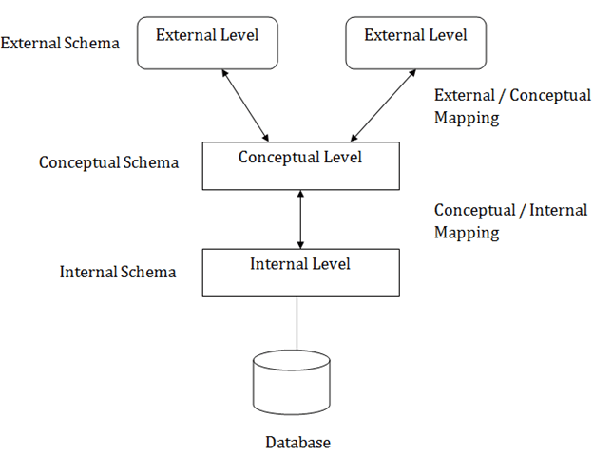

Fig 1.2

**CHAPTER 2 INTRODUCTION TO PROJECT RAILWAY RESERVATION MANAGEMENTSYSTEM**

2.1 Brief description

● The mini-project entitled “Railway reservation management system“ is developed as apart of the fifth semester DBMS laboratory, for the partial fulfillment of the requirement for the BE( Information Science) course.

● Our website has various kinds of information that helps regarding booking of tickets via railways .

● Users will be able to search the train availability ,the exact fare ,the arrival and departuretime of the train and they can also book the ticket by using the debit ,credit or master card and after booking the ticket if the user want to cancel it then they can easily do it also.

Objectives The objective of the online railway reservation management system Project is to design software to fully automate the process of issuing a railway ticket. That is:-

1. To create a database of the trains

2. To search the trains it’s arrival and departure time,distance between source and destination.

3.To check the availability of the ticket.

4. To calculate fare.

5.To book the ticket.

6.To cancel the ticket if necessary

2.2 Scope

● Railway passengers frequently need to know about their ticket reservation status, ticket availability on a particular train or for a place, train arrival or departure details, special trains etc.. Customer information centers at the railway stations are unable to serve such queries at peak periods.

● The number of the reservation counters available to the passengers and customers are very less.

● On most of the reservation systems there are long queues, so it takes a long time for any individual to book the ticket.As now there are no call centers facilities available to solve the queries of the passengers. ● The online railway ticket reservation system aims to develop a web application which aims at providing trains details, trains availability, as well as the facility to book ticket in online for customers.

● So, we thought of developing a web based application which would provide the users all these facilities from his terminal only as well as help them in booking their tickets. The Application was to be divided into two parts namely the user part , and the administrator part. And each of these has their corresponding features.We decided to give the name of the website “RAILWAY RESERVATION MANAGEMENT SYSTEM”.The online railway ticket reservation system is developed using ASP.NET with C# as the backend in the .NET Framework.

Analysis

Railway reservation management system is a online ticket booking website, which is capable of booking ticket and serach the train availavility . This website is mainly created to fulfil the following requirements, it comprises of the following properties:-

● A central database that will store all information.

● An online website that will provide real- time information about the availability of tickets their prices . ● Every registered user is able to view his booking id that has been made in his/her name.

● Every registered user can change his password any time he wants to change.

2.3 **Table description**

USERINFO table has a attributes f_name ,I_name ,email,password,gender, marital,dob,mobile,ques,ans

2.3.2 TRAIN LIST TRAIN LIST

table has a atrributes number,name,origin,destination,arrival,departure,mon,tue,wed,thu,fri,sat,sun,1A,2A,3A,SL,General and number is used as a primary key

2.3.3 SEATS SEATS

table has the attribute train_no,train_name,doj,1A,2A,3A,AC,CC,SL is used

2.3.4 INTERLIST INTERLIST

table has the attribute number,st1,st1arri,st2,st2arri,st3,st3arri,st4,st4arri,st5,st5arri,ori,oriarri,dest,desarri,name,mon,tue,wed,thu,fri,sat,sun

2.3.5 BOOKING BOOKING

table has theattributeuname,Tnumber,class,doj,DOB,fromstn,tostn, name,age,sex,status

2.4 TRIGGERS

A trigger is a special type of stored procedure that automatically executes when a event occurs in the database server.

Chapter 3 3.1.

ER Diagram

DESIGN

An entity–relationship model describes inter-related things of interest in a specific domain of knowledge. An ER model is composed of entity types and specifies relationships that can exist between instances of those entity types.

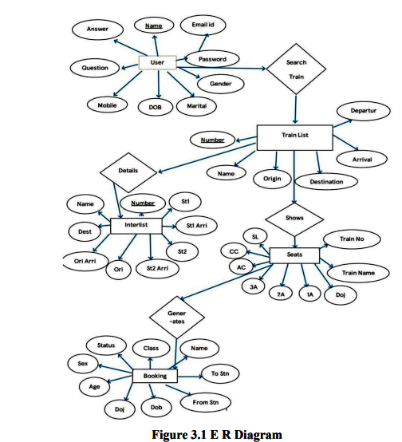

This ER Diagram gives a brief idea about the relations existing between the tables and tells about the primary and the foreign keys being used in this Database.

3.2 **NORMALIZATION**

3.3.1 First Normal Form (1NF)

As the domain of all attributes of all relations in the database has atomic value and no tuples can have a set of these values, all relations are in 1NF.

3.3.2 Second Normal Form (2NF)

As there is no partial dependency in the database, i.e. all nonprime attributes of a relation are fully functionally dependent on the primary key of the relation schema, all relations are in 2NF.

3.3.3 Third Normal Form (3NF)

As all relations are in 2NF and no non-prime attribute of a relation schema is transitively dependent on the primary key, all relations are in 3NF.

3.3 SCHEMA DIAGRAM

A database schema can be represented in a visual diagram, which shows the database object and their relationship which represents the logical view of the database and how the relationships among them are represented.

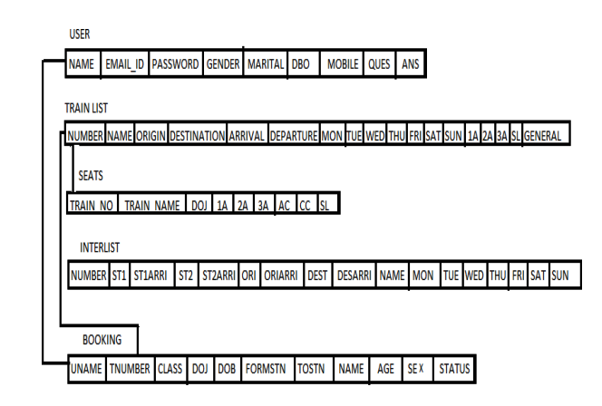

**CHAPTER - 4 HARDWARE AND SOFTWARE REQUIREMENTS**

4.1 FUNCTIONAL AND NON FUNCTIONAL REQUIREMENTS

4.1.1 Functional or specific Requirements

The required software is used for ordering food online. The system should satisfy the following requirements:

1. Logging into the system

2. Signup option

3. View Menu Details

4. Order Option

6. View User Orders

7. Logout option

4.1.2 Non functional Requirements

All of the application data is stored in an Oracle database, and therefore an Oracle Database must also be installed on the host computer. As with Apache2, this software is freely available and can be installed and run under most operating systems. The server hardware can be any computer capable of running both the web and database servers and handling the expected traffic. For a small scale restaurant that is not expecting to see much web traffic, an average personal computer may be appropriate. Once the site starts generating more hits, though, it will likely be necessary to upgrade to a dedicated host to ensure proper performance. The exact cut-offs will need to be determined through a more thorough stress testing of the system.

4.2 **Hardware requirement**

● A desktop or laptop with a proper internet connection

● 2 500GB or 60GB of the hard disk

● 3.4GB 2GB of the RAM

● 4 Windows 7 or 8 or 10 Operating system

4.3 **Software requirements**

4.3.1 Server side

1. Programming language: PHP 5.6.31

2. Web Server: Apache 2.4.27

3. Database: SQL 5.7.19 4.3.2

Client side

1. Programming language: JAVASCRIPT, HTML, CS

2. OS: windows7/8/10

3. MYSQL server

4.3.1.1 PHP

PHP is a server-side scripting language designed primarily for web development but also used as a general programming language PHP code may be embedded into HTML or HTML5 markup or it can be used in combination with various web template systems, web content management systems, and web frameworks. PHP code is usually processed by a PHP interpreter implemented as a module in the web server. The web server software combines the results of the interpreted and executed PHP code, which may be any type of data, including images, with the generated webpage.

4.3.1.2 WEB SERVER: APACHE

Apache is the most widely used web server software. Developed and maintained by Apache Software Foundation, Apache is open-source software available for free. It runs on 67% of all web servers in the world. It is fast, reliable, and secure. It can be highly customized to meet the needs of many different environments by using extensions and modules. Most WordPress hosting providers use Apache as their web server software. However, WordPress can run on other web server software as well.

4.3.1.3 HTML

HTML is an acronym that stands for HyperText Markup Language. HyperText: HyperText simply means "Text within Text". A text has a link within it, is a hypertext. Every time you click on a word that brings you to a new webpage, you have clicked on a hypertext. Markup language: A markup language is a programming language that is used to make text more interactive and dynamic. It can turn a text into images, tables, links, etc. An HTML document is made of many HTML tags and each HTML tag contains different content.

4.3.1.4 JAVASCRIPT

Javascript is a dynamic computer programming language. It is lightweight and most commonly used as a part of web pages, whose implementations allow client-side script to interact with the user and make dynamic pages. It is an interpreted.

**CONCLUSION**

Our system can successfully give information on any train,find trains running between twostations ,book tickets and cancel tickets.This system could be used for official trainbooking.However several other features could be added like booking meals on trains etc. Also payment gateways have to be implemented to make sure the transactions happen securely.

**FUTURE ENHANCEMENT**

● We can even further make it private and secured by implementing Login IDs and encrypting them with passwords.

● We can give away this software for more number of people and organizations to conduct a Beta Testing and based upon the results we can just make those changes and be assured of the application developed.

● We can make it more space and resource efficient so that this application consumes lesser RAM and ROM and battery power (if available).

**REFERENCES**

[1] https://github.com/

[2] <http://php.net/>

[3] <https://www.http://en.wikipedia.org/wiki/PHP>

**Snapshots**

* HOME PAGE

This is the first window when the application is executed as shown

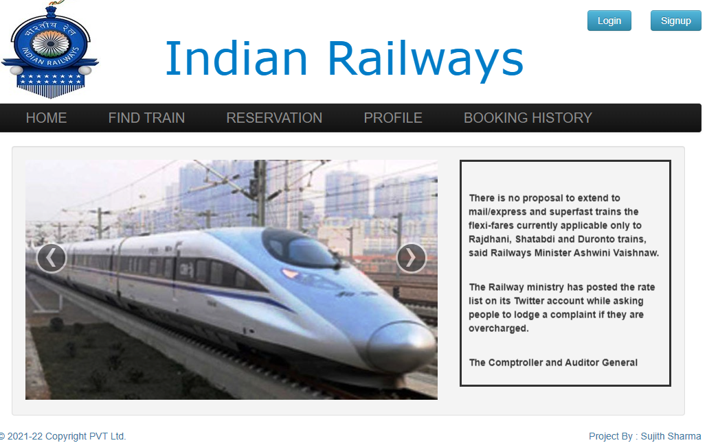

* SIGN UP PAGE

The page allows admin to sign up to database as shown

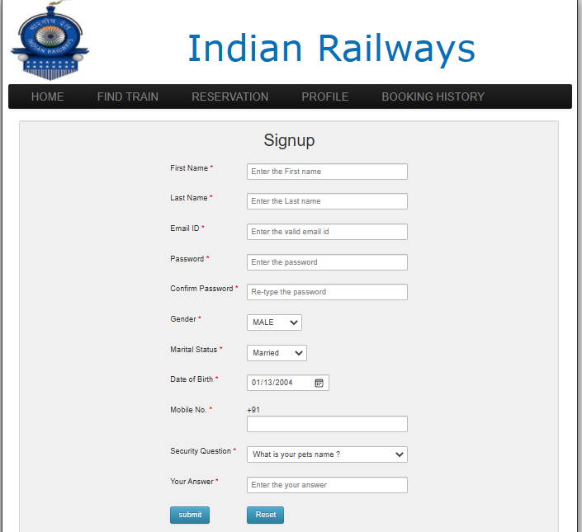

* ADMIN LOGIN PAGE

This page allows admin to login and make changes to data base as shown

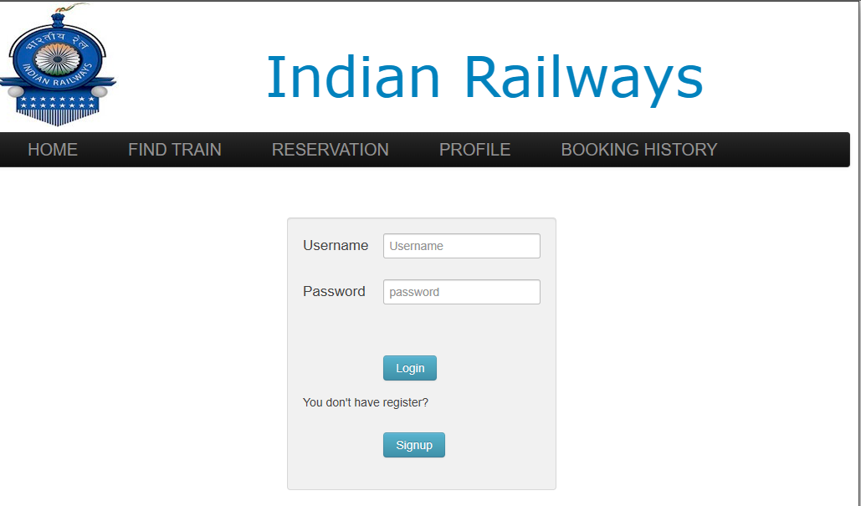

* ADMIN FIND TRAIN PAGE

This page allows admin to find the train as shown

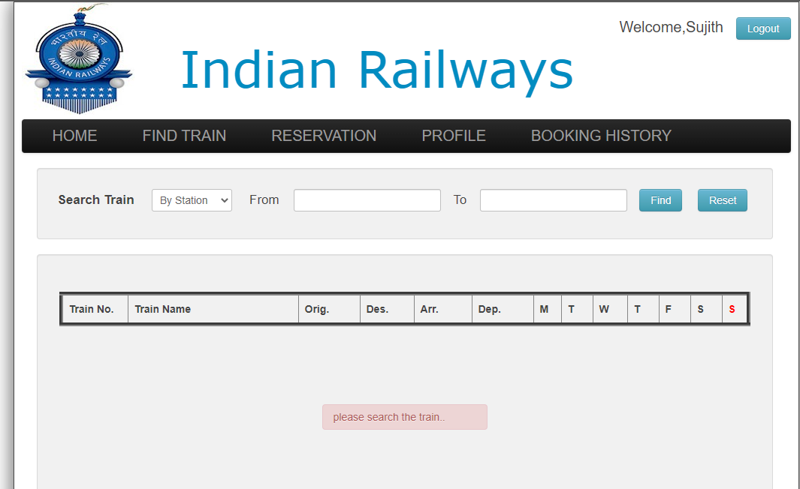

* ADMIN BOOKING RESERVATION PAGE

This page allows admin to book the tickets as show

